

**Module 6: Jenkins Assignment - 2**

DevOps Certification Training

**Tasks To Be Performed:**

1. Add 2 nodes to Jenkins master
2. Create 2 jobs with the following jobs:
   1. Push to test
   2. Push to prod
3. Once a push is made to test branch, copy Git files to test server
4. Once a push is made to master branch, copy Git files to prod server

------------------------------------------------------ANSWER-----------------------------------------------------------------

1. Created 3 instance

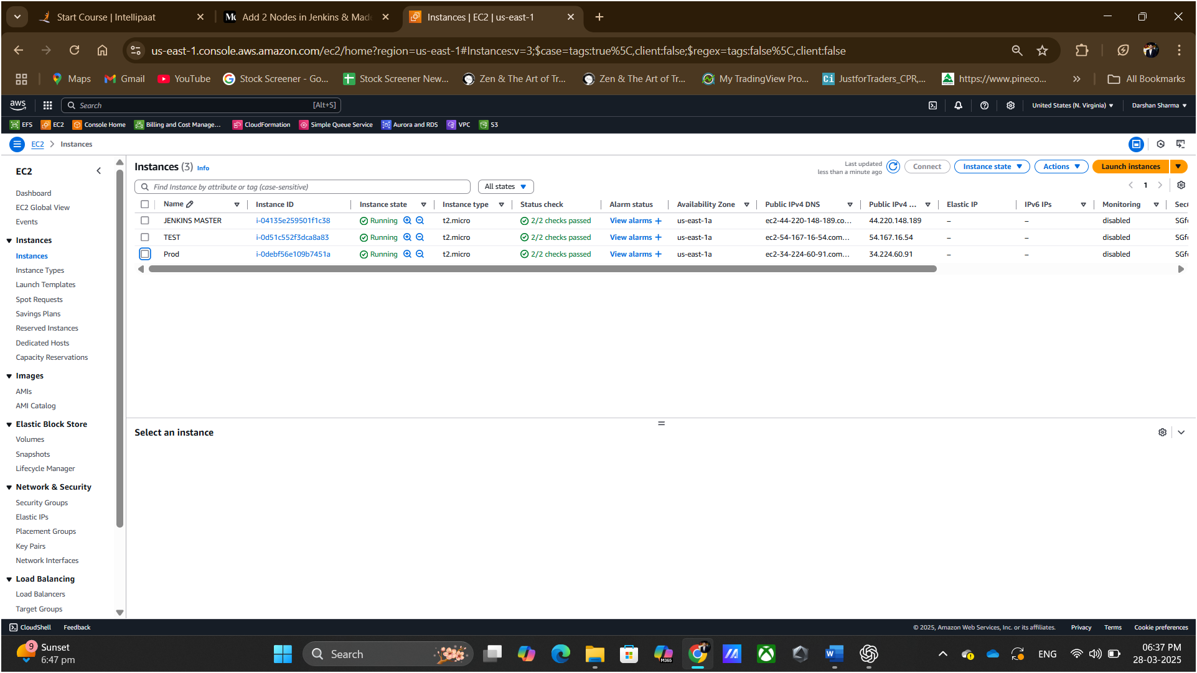

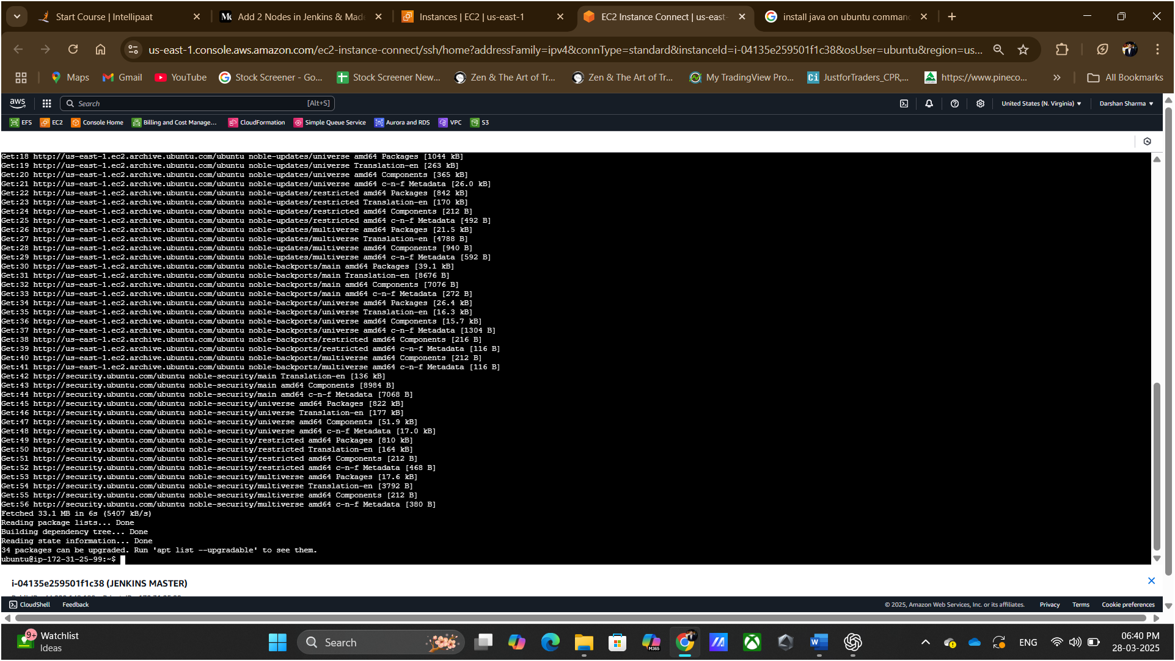

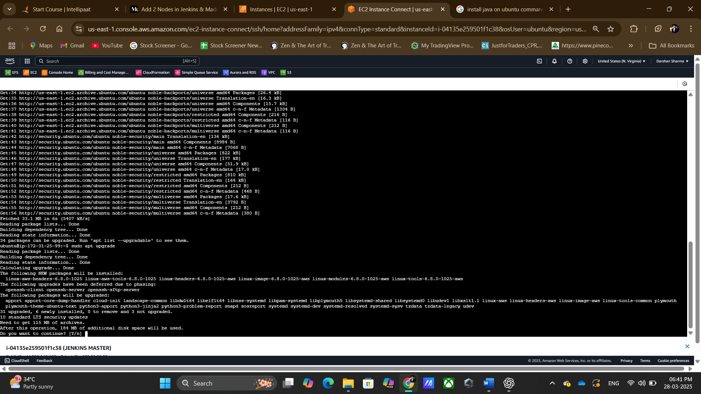

JAVA version check

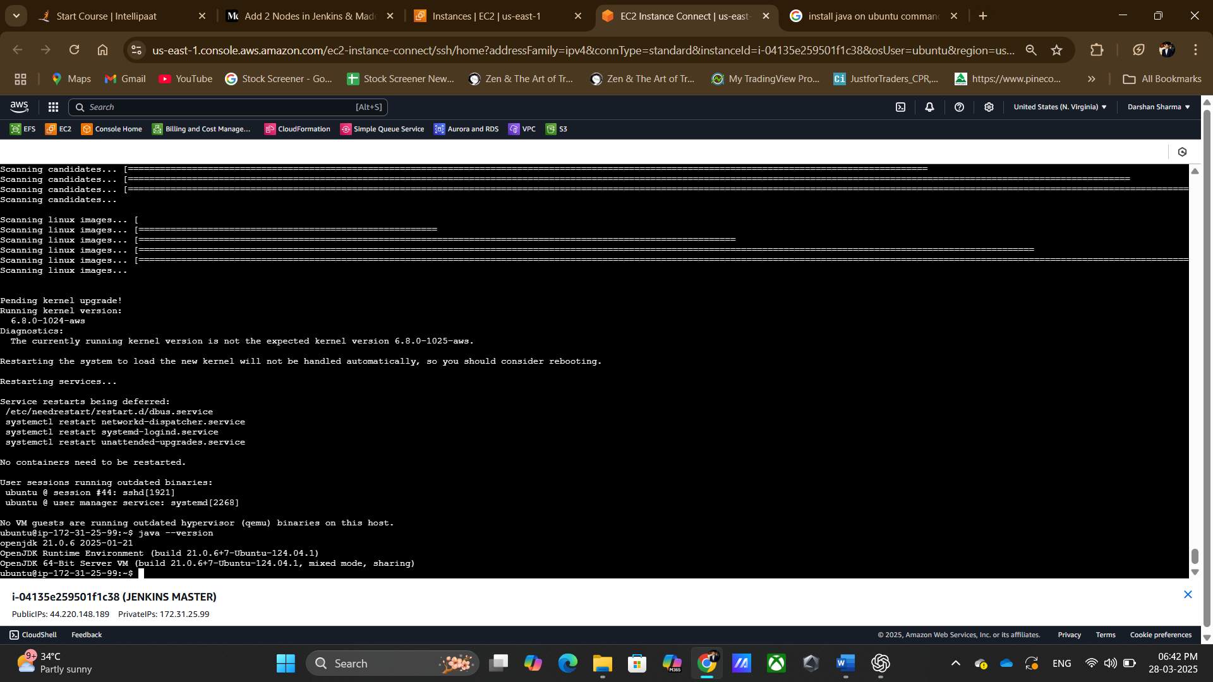

Installing Jenkins in Master using command

sudo wget -O /usr/share/keyrings/jenkins-keyring.asc \

https://pkg.jenkins.io/debian-stable/jenkins.io-2023.key

echo "deb [signed-by=/usr/share/keyrings/jenkins-keyring.asc]" \

https://pkg.jenkins.io/debian-stable binary/ | sudo tee \

/etc/apt/sources.list.d/jenkins.list > /dev/null

sudo apt-get update

sudo apt-get install Jenkins

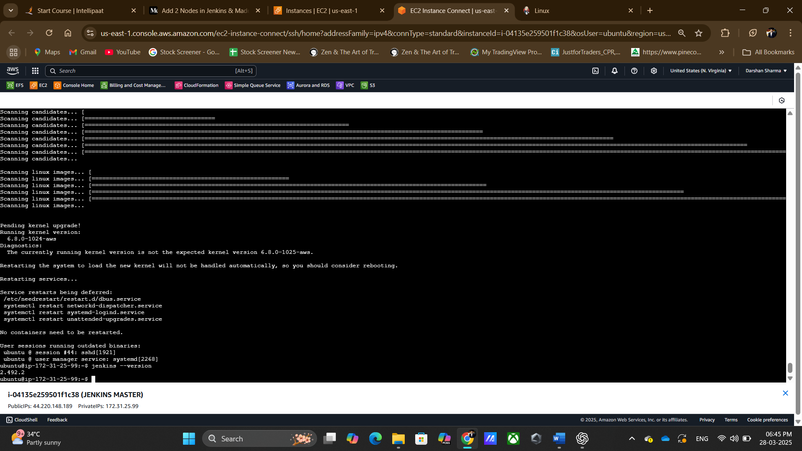

Jenkins status

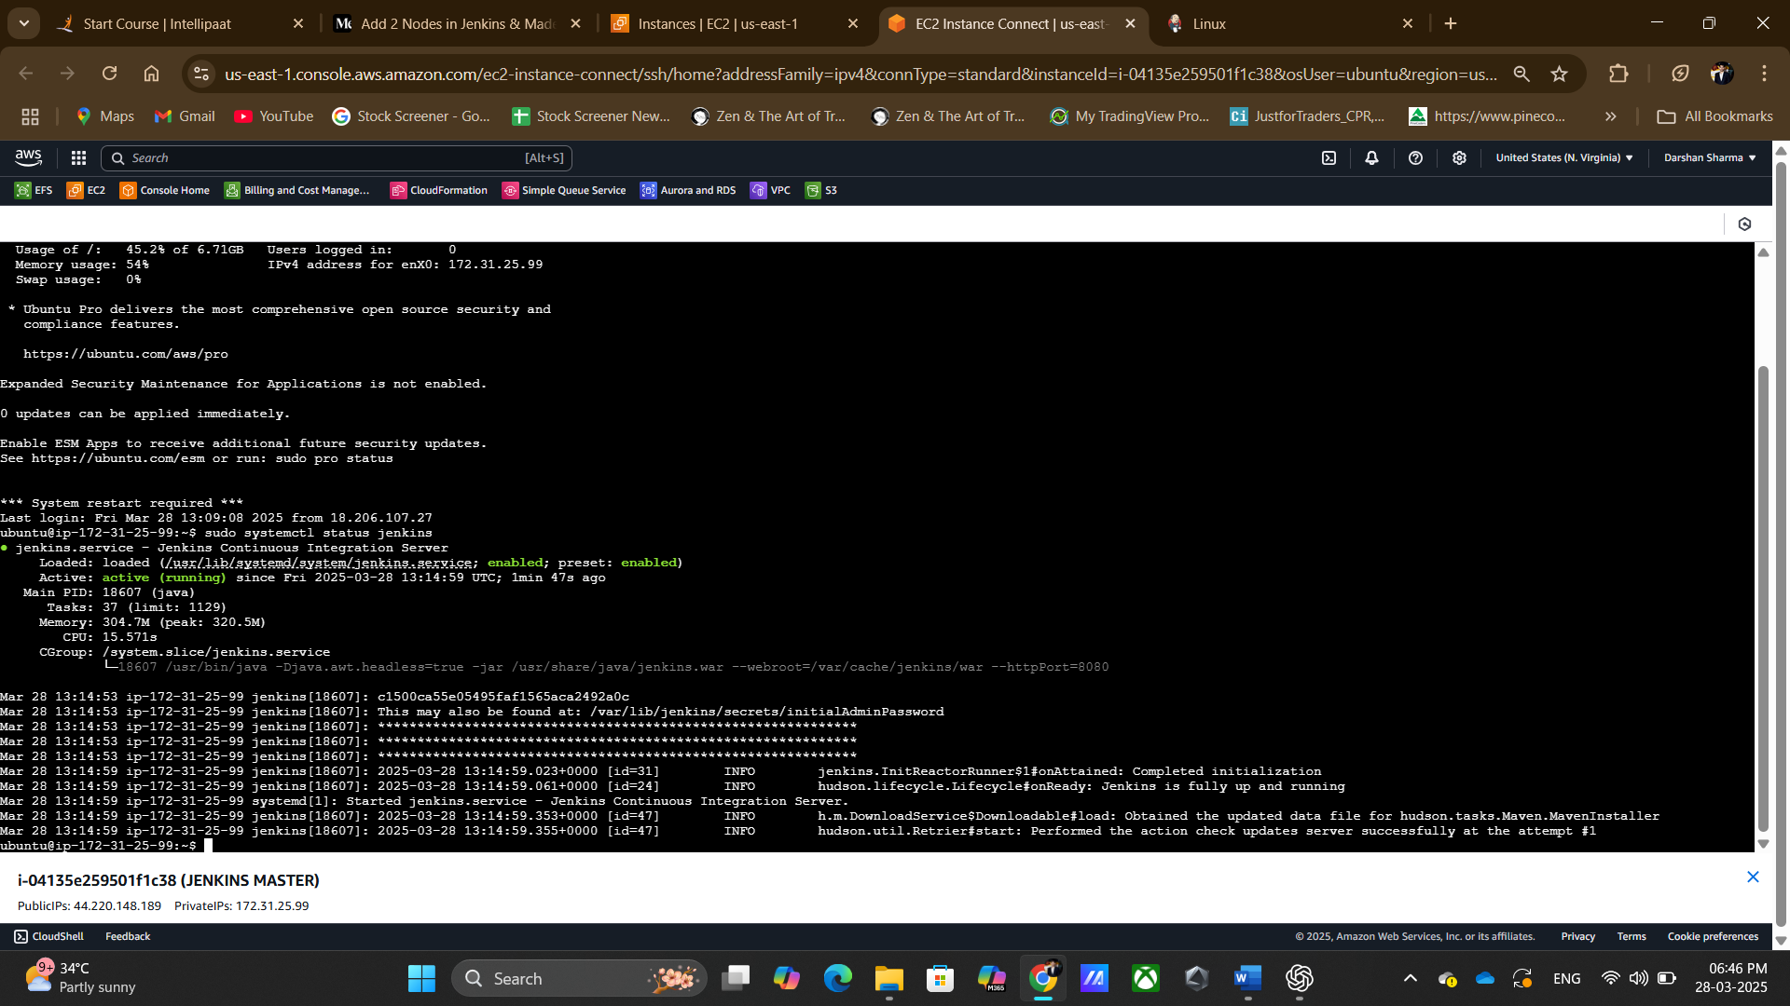

Connecting to Jenkins

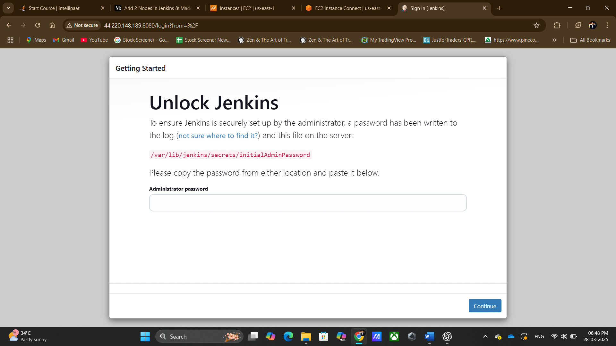

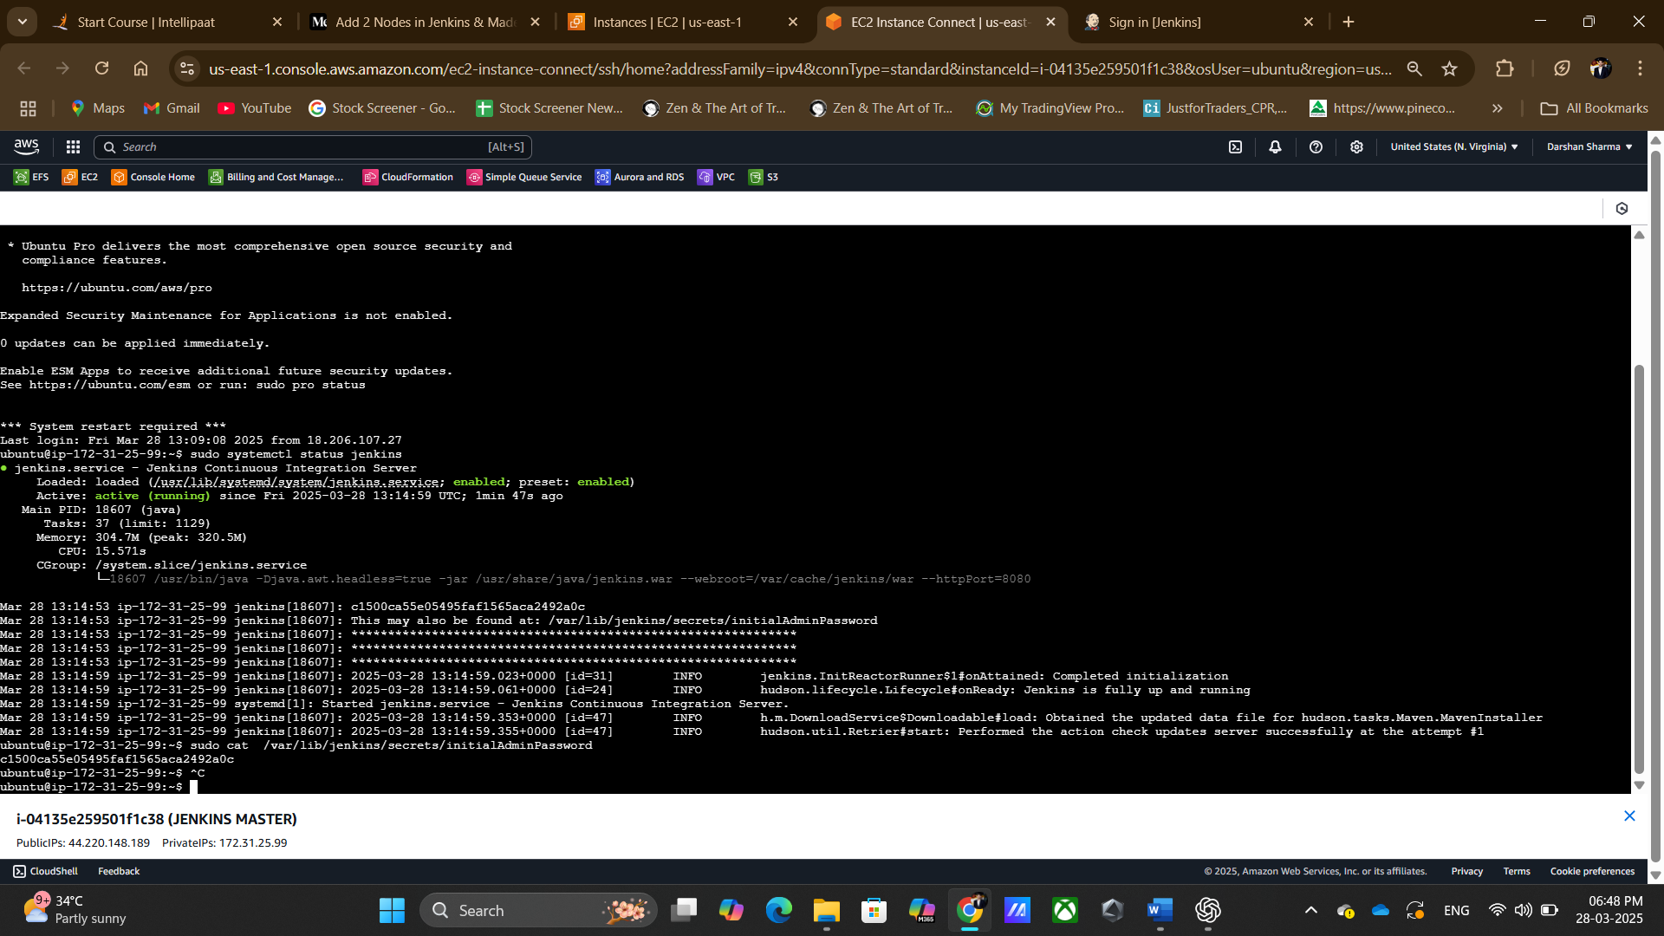

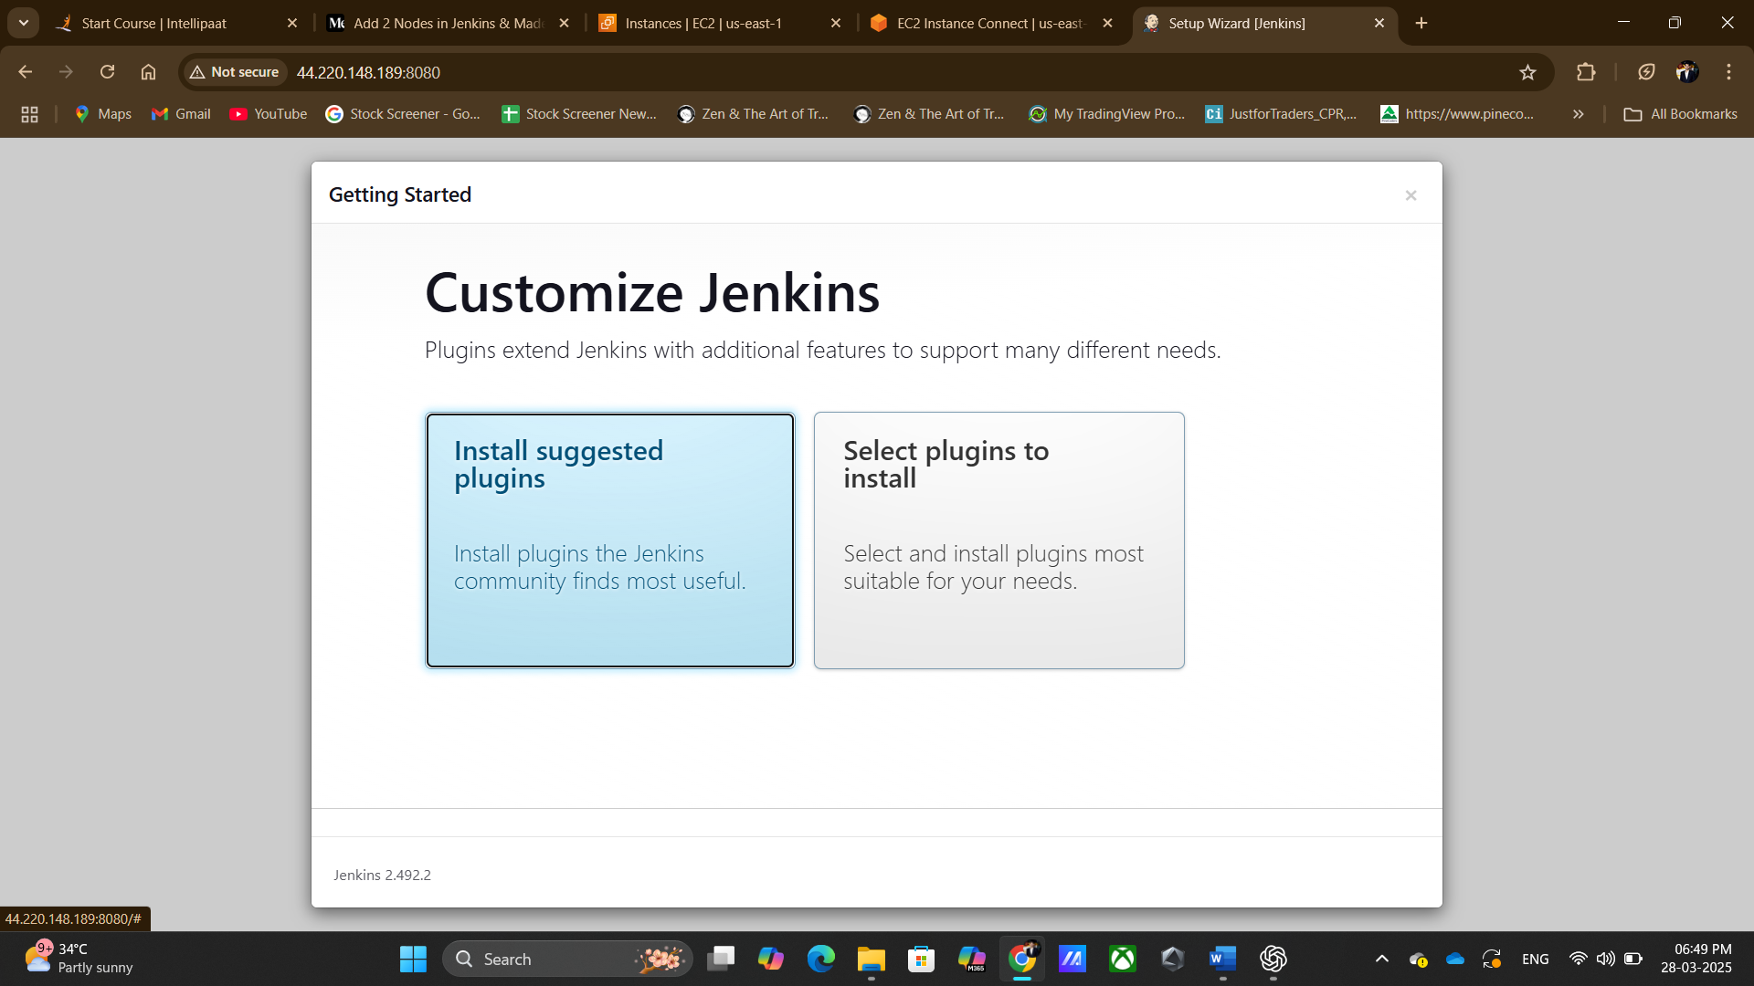

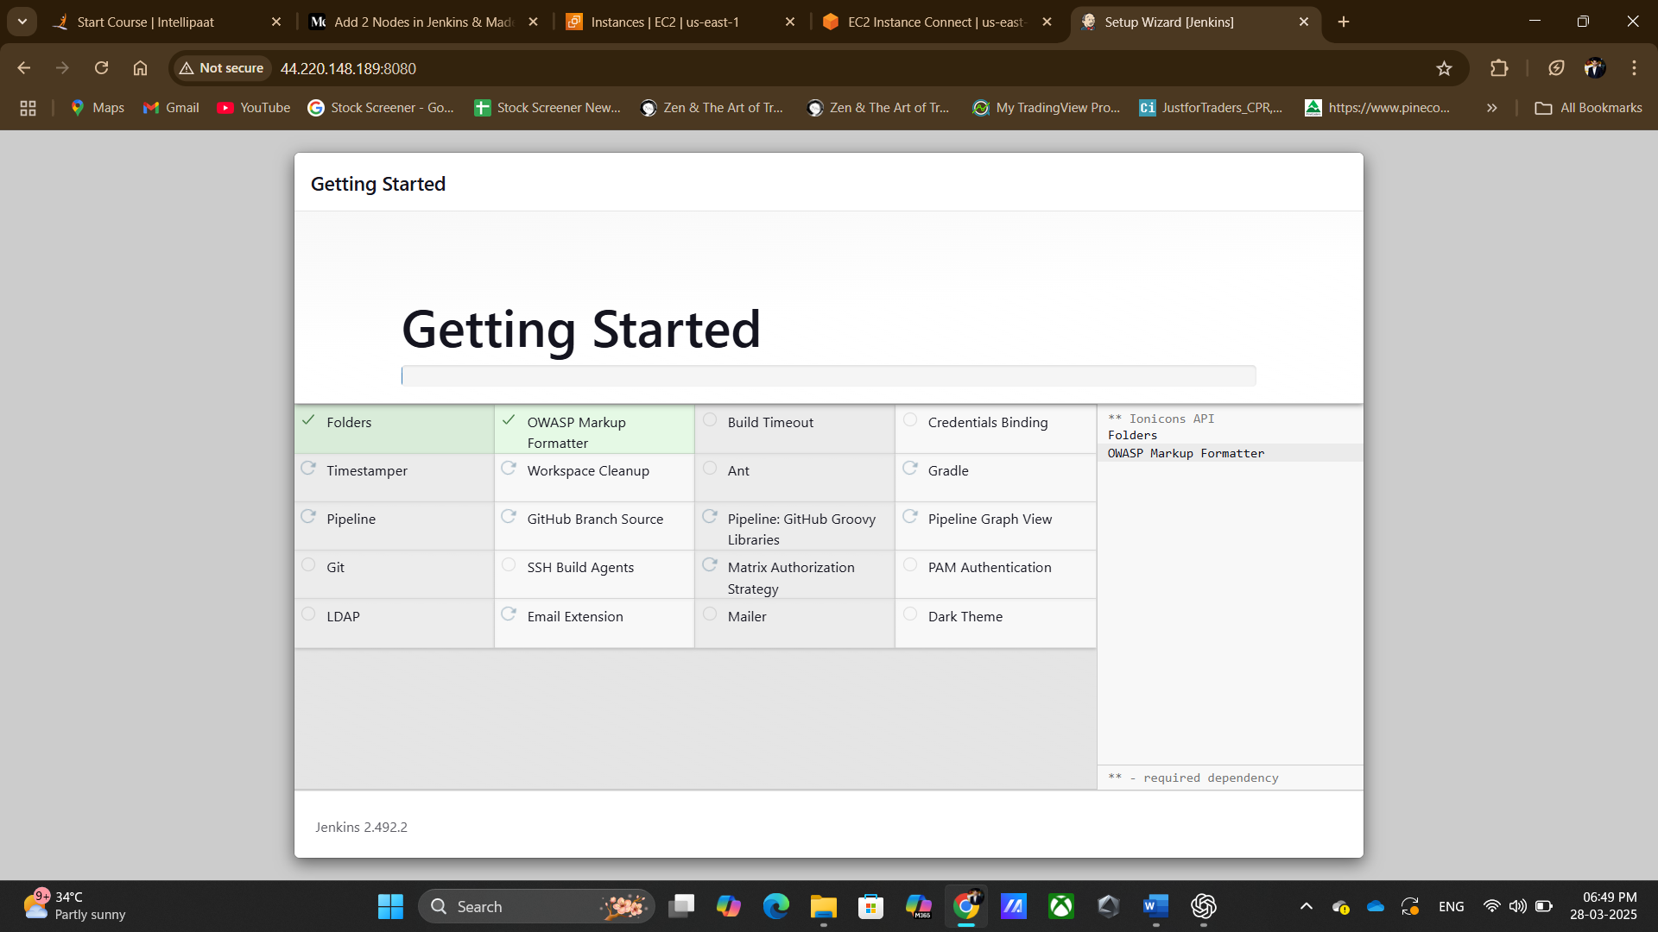

Done login

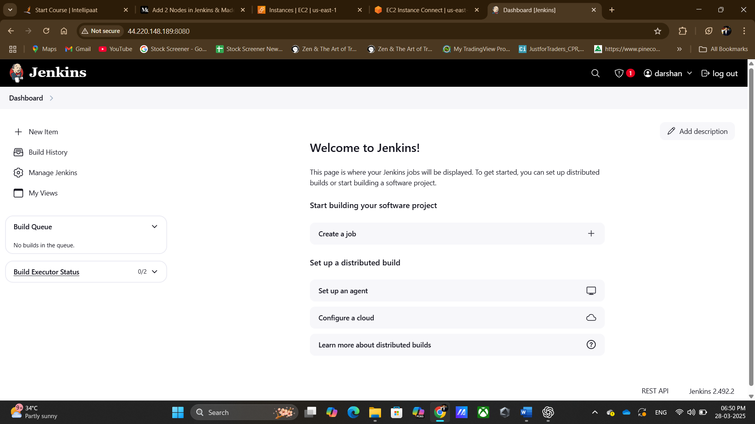

Installing java in test & Prod server

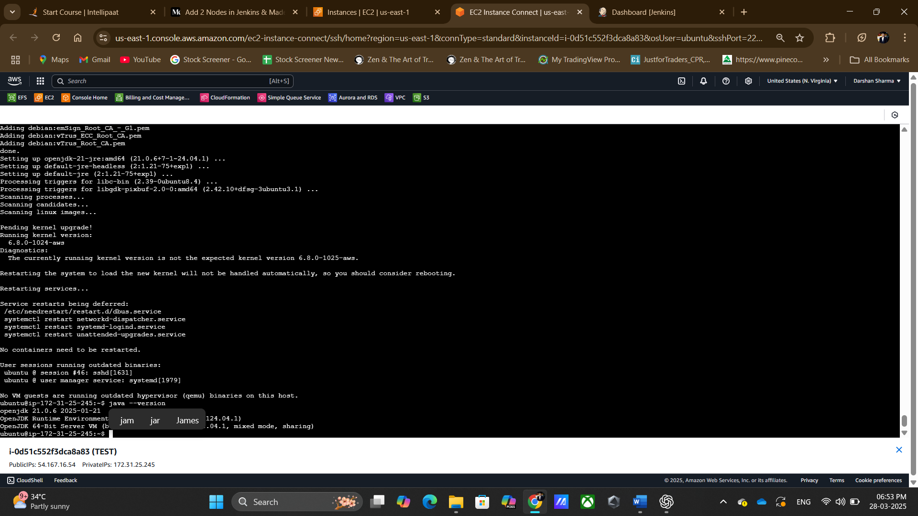

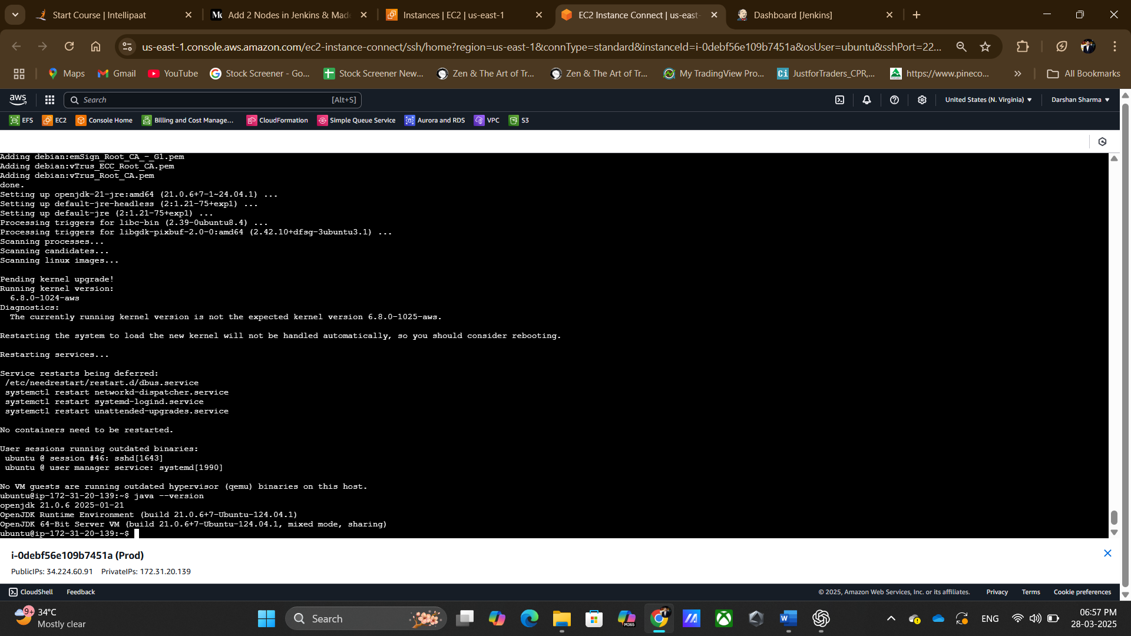

Creating node for test & PROD

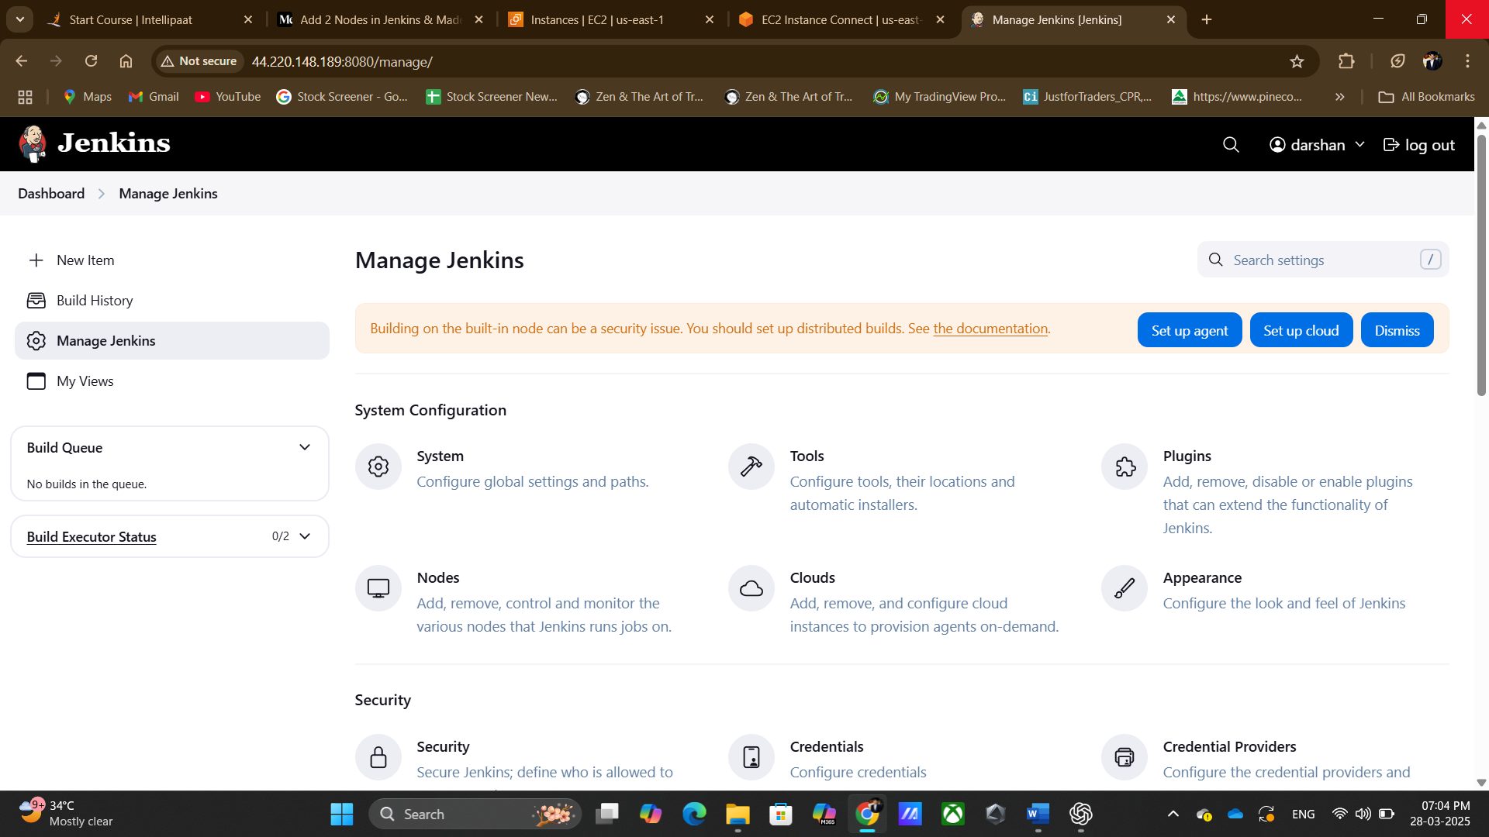

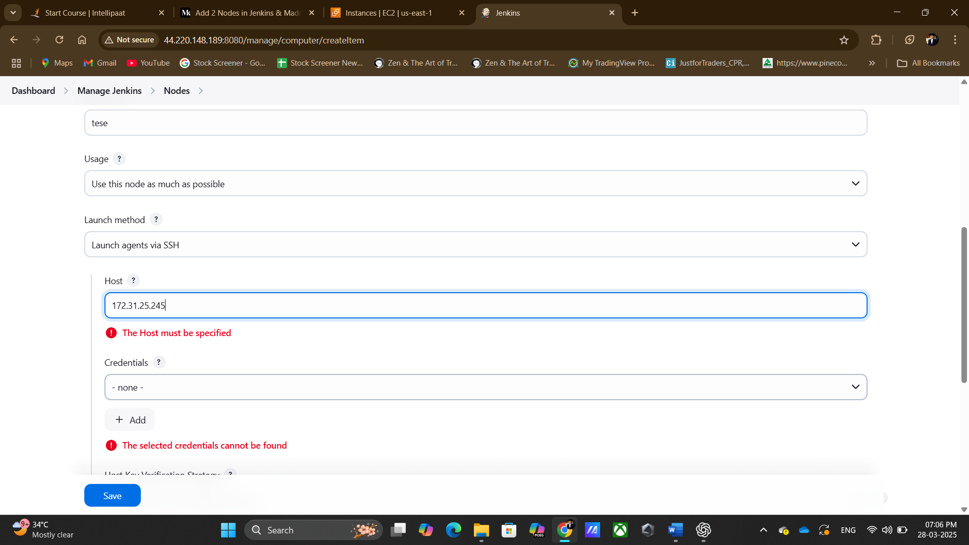

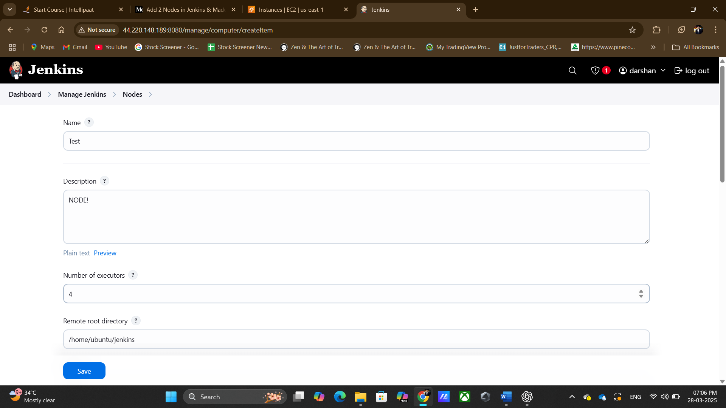

Test node is connected

Both instances are connected

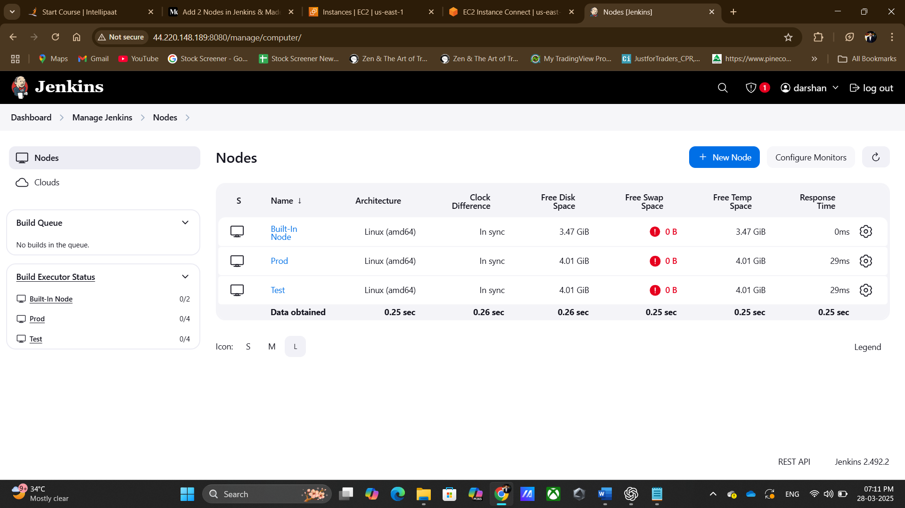

Using existing GIT Repository https://github.com/d2arshan/assignment1

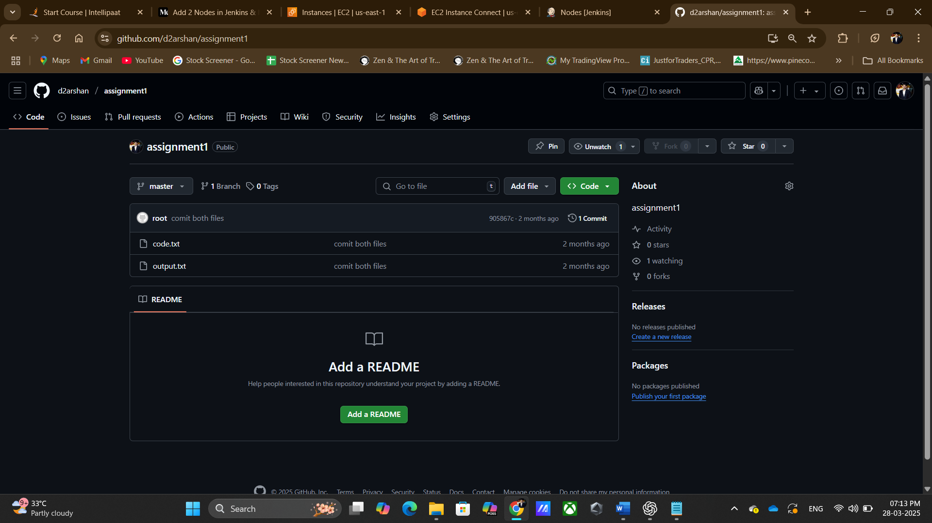

Creating Jenkins job 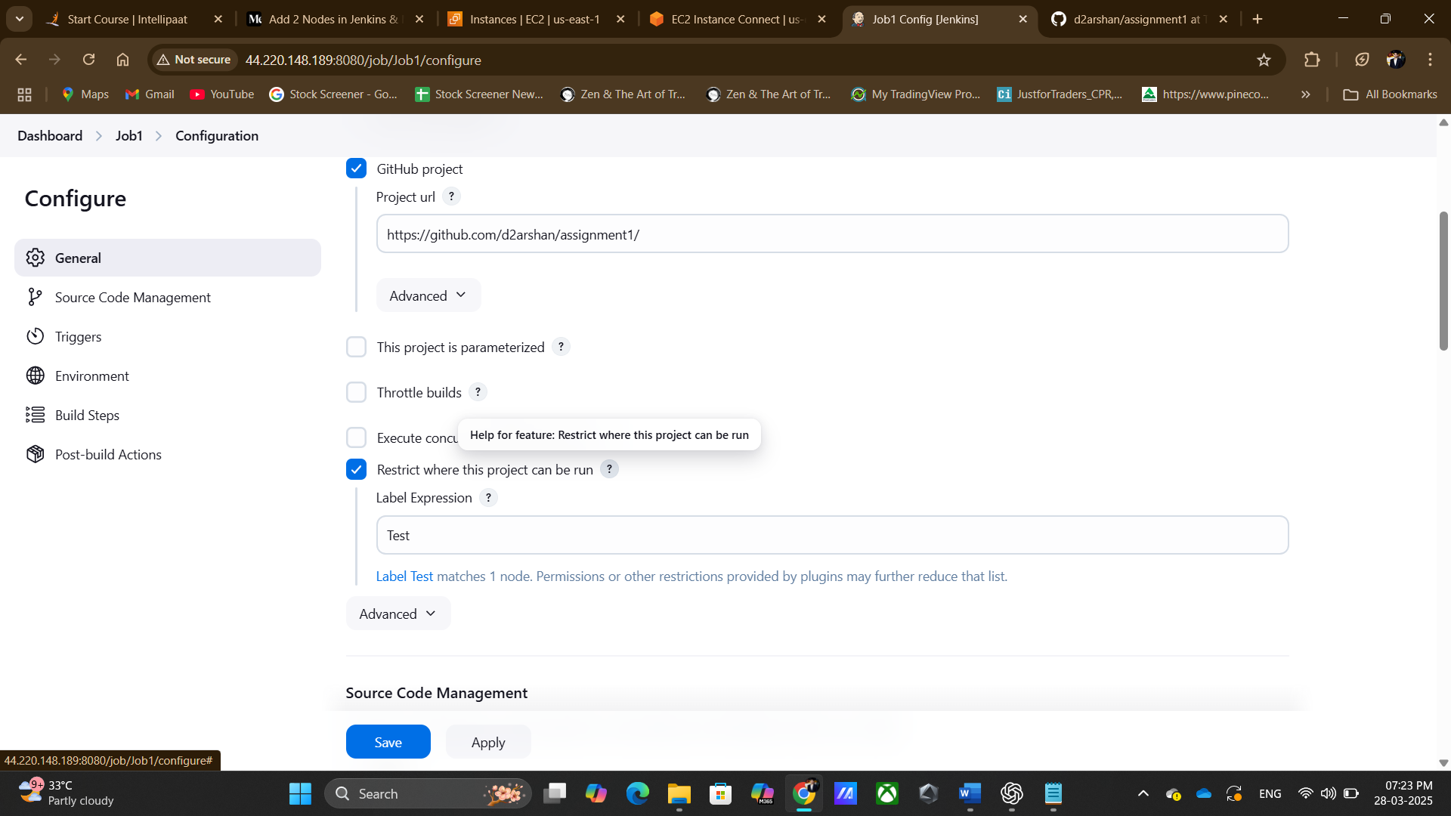

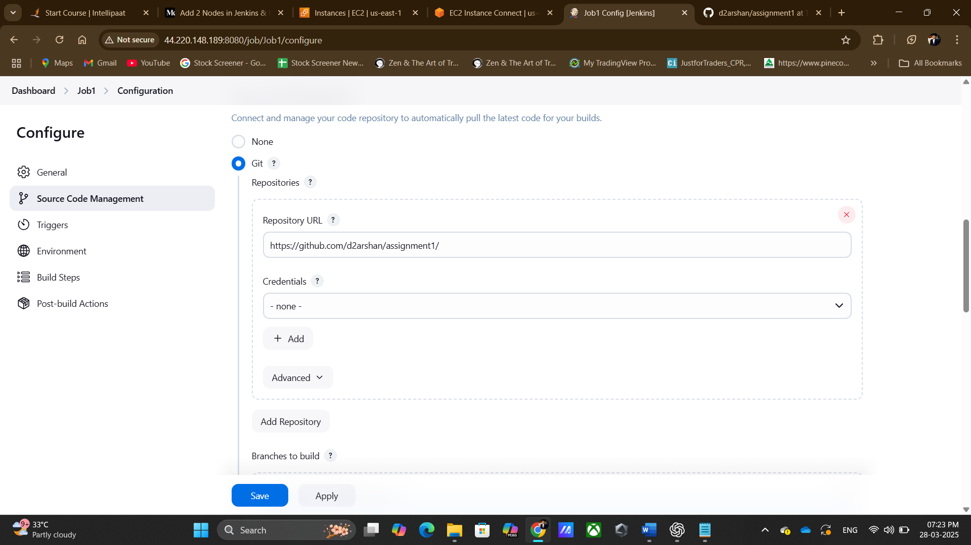

Job run successful

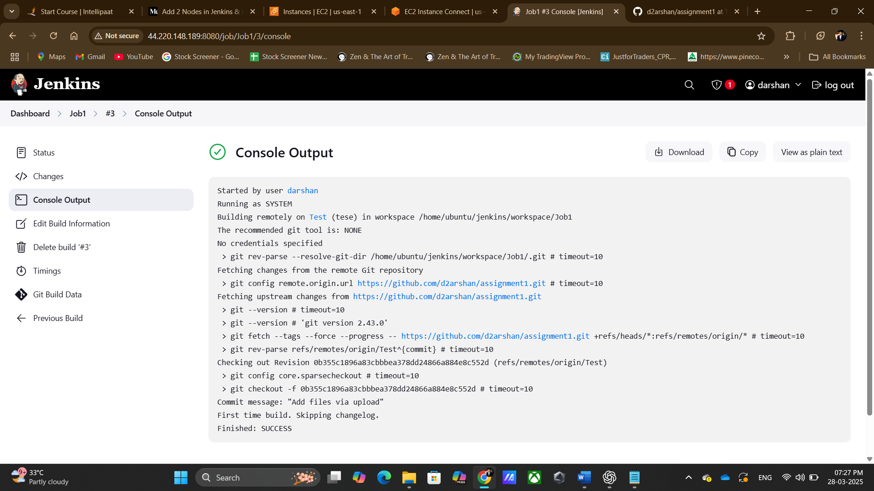

Now checking files in test instance

Same files found

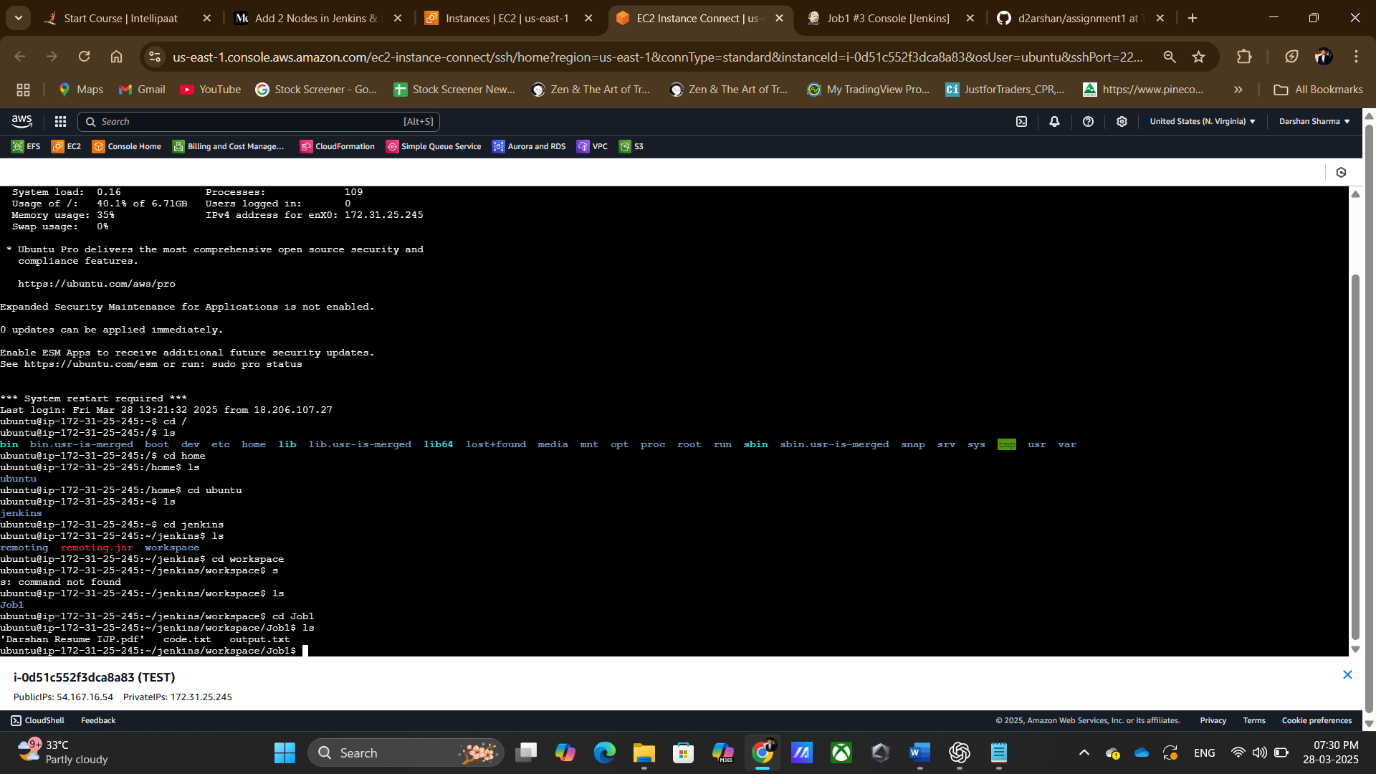

Job 2 execution successful

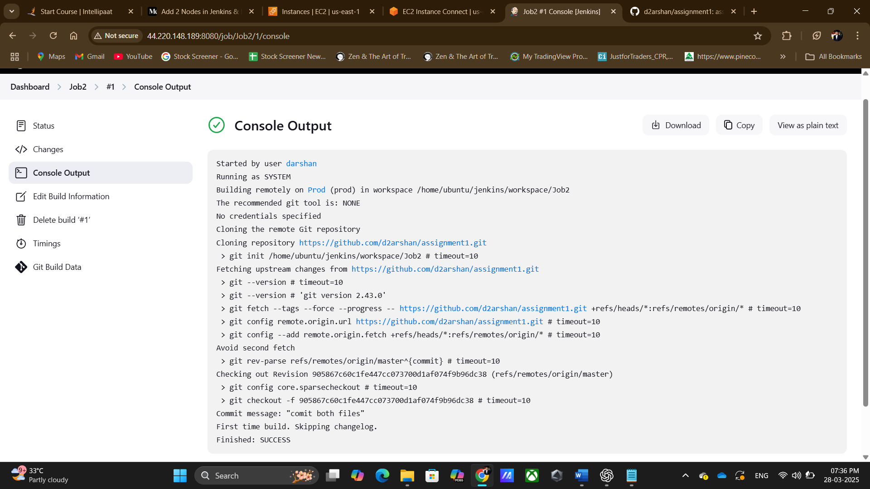

Found same files in prod

